**JEE Practical Project**

**Task**

1. **Create JavaEE application with the following functionality**
   1. Login Page - this is the initial page that the user accesses. It requires username and password, validates them and forwards the user to a success page
   2. Add Authentication filter, that will restrict access to the secured resources

**Execution**

1. **Setup environment**
   1. Install JDK, Eclipse and add Wildfly
   2. Install Jboss tools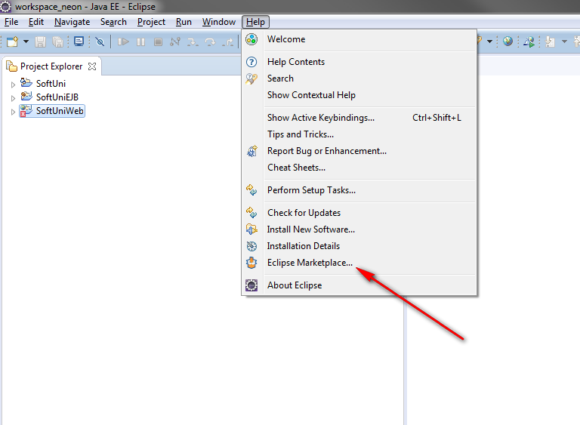

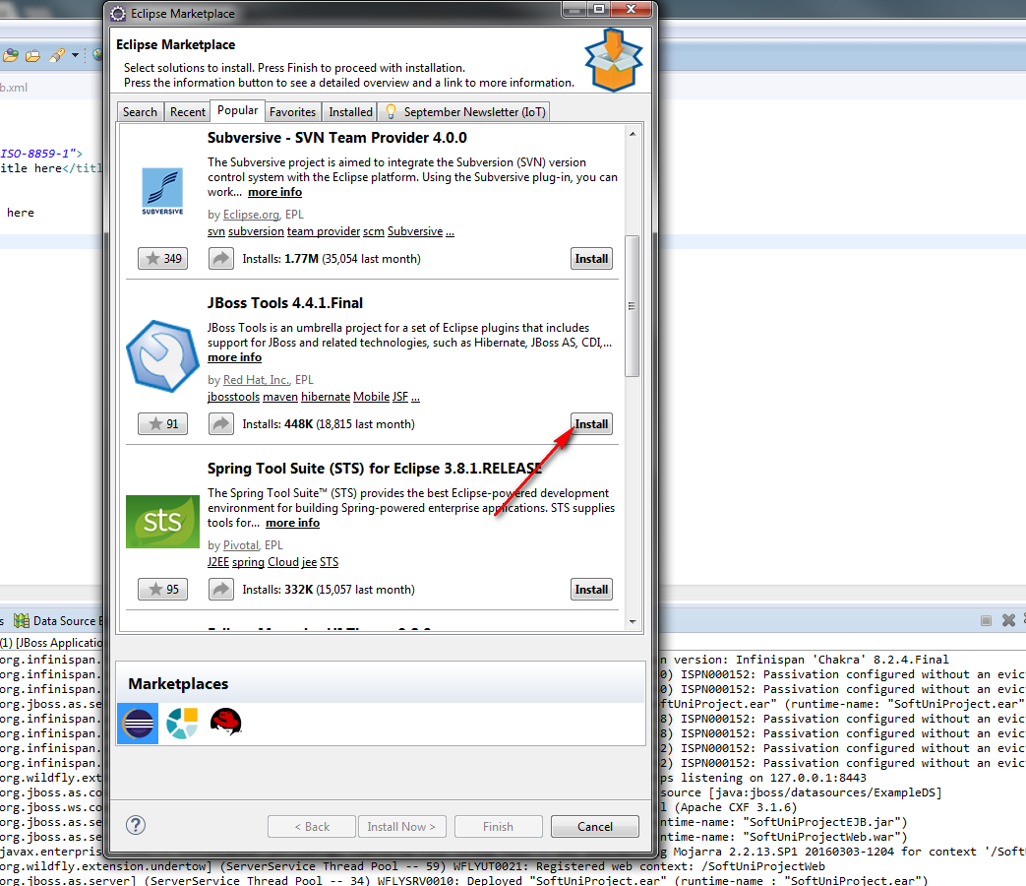

Follow the wizard and restart Eclipse

1. **Create JEE project with JSF and EJB (EJB will be used later)**
2. **Check JSF configuration in web.xml**

<?xml version=*"1.0"* encoding=*"UTF-8"*?>

<web-app xmlns:xsi=*"http://www.w3.org/2001/XMLSchema-instance"* xmlns=*"http://java.sun.com/xml/ns/javaee"* xsi:schemaLocation=*"http://java.sun.com/xml/ns/javaee http://java.sun.com/xml/ns/javaee/web-app_3_0.xsd"* id=*"WebApp_ID"* version=*"3.0"*>

<display-name>SoftUniProjectWeb</display-name>

<welcome-file-list>

<welcome-file>index.jsp</welcome-file>

</welcome-file-list>

<servlet>

<servlet-name>Faces Servlet</servlet-name>

<servlet-class>javax.faces.webapp.FacesServlet</servlet-class>

<load-on-startup>1</load-on-startup>

</servlet>

<servlet-mapping>

<servlet-name>Faces Servlet</servlet-name>

<url-pattern>*.html</url-pattern>

</servlet-mapping>

</web-app>

1. **Download PrimeFaces and import it into the project**
   1. [**http://www.primefaces.org/downloads**](http://www.primefaces.org/downloads)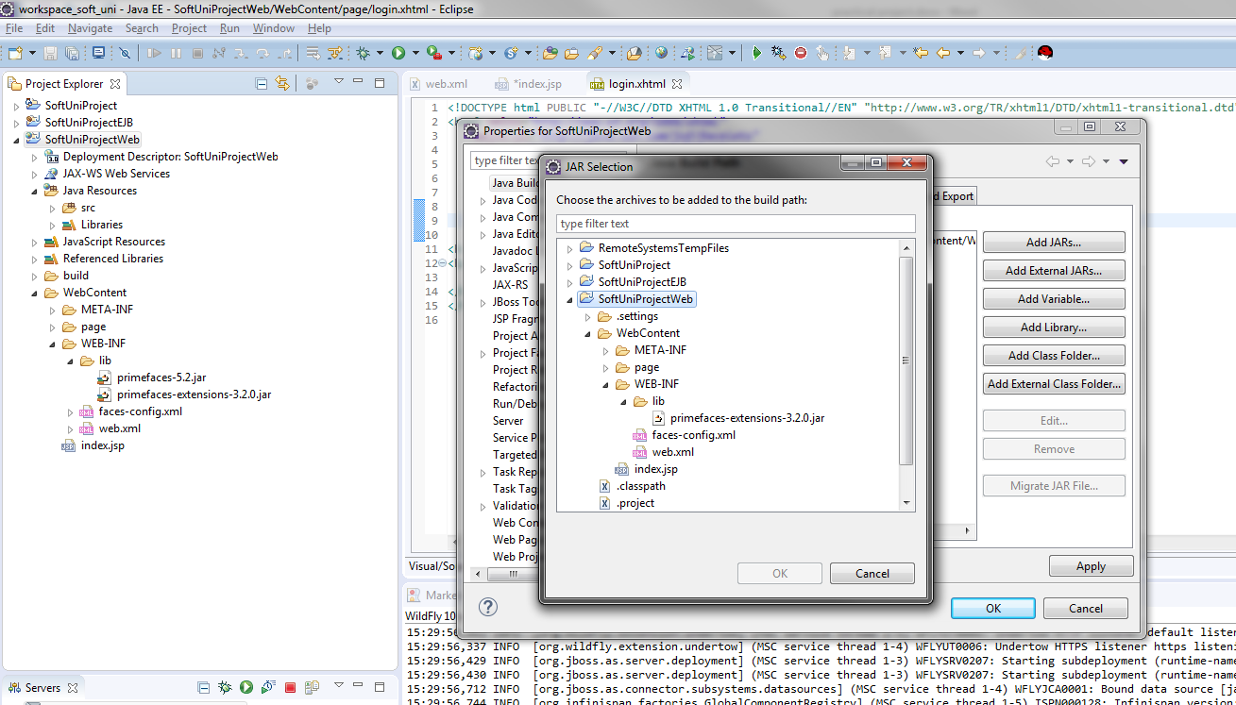
2. **Create login.jsp file in WebContent with the following content:**

<%@page contentType=*"text/html"* pageEncoding=*"UTF-8"* %>

<% response.sendRedirect(request.getContextPath() + "/page/login.html"); %>

1. **Create folder, named page in WebContent**
2. **Crate login.xhtml file in pages folder**
3. **Add extra libraries to the web project**

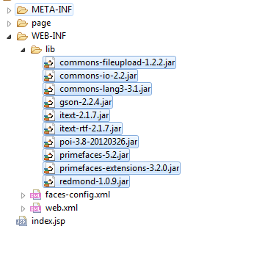

1. **Create java package and Login bean**

**package** bg.softuni.web;

**import** java.io.Serializable;

**import** javax.annotation.PostConstruct;

**import** javax.faces.application.FacesMessage;

**import** javax.faces.bean.ManagedBean;

**import** javax.faces.bean.RequestScoped;

**import** javax.faces.context.FacesContext;

**import** javax.inject.Inject;

**import** javax.servlet.http.HttpServletRequest;

**import** org.apache.commons.lang3.StringUtils;

/**

* The purpose of this class is to provide backend functionality of the login

*/

@ManagedBean(name = "loginBean")

@RequestScoped

**public** **class** LoginBean **implements** Serializable {

**private** **static** **final** **long** ***serialVersionUID*** = 1L;

//beans.xml need to be added in WEB-INF in order CDI to work

@Inject

**private** HttpServletRequest request;

**private** String username;

**private** String password;

**private** **static** **final** String ***SUCCESS_LOGIN_REDIRECT*** = "/page/success?faces-redirect=true";

**private** **static** **final** String ***LOGIN_PAGE_REDIRECT*** = "/page/login?faces-redirect=true";

@PostConstruct

**public** **void** init() {

//**TODO**

}

/**

* Implement application login logic

*

* **@return**

*/

**public** String login() {

**if** (StringUtils.*isBlank*(username) || StringUtils.*isBlank*(password)) {

FacesContext.*getCurrentInstance*().addMessage(**null**, **new** FacesMessage("Invalid credentials"));

**return** "";

} **else** **if**("admin".equals(username) && "123".equals(password)){

// If we want to avoid using CDI for accessing the request we can take it from FacesCondex by using:

// HttpServletRequest request = (HttpServletRequest)FacesContext.getCurrentInstance().getExternalContext().getRequest();

request.getSession().setAttribute("LOGGED_USER", username);

**return** ***SUCCESS_LOGIN_REDIRECT***;

}

FacesContext.*getCurrentInstance*().addMessage(**null**, **new** FacesMessage("Invalid credentials"));

**return** "";

}

/**

* Implement application logout logic

*

* **@return**

*/

**public** String logout() {

request.getSession().invalidate();

**return** ***LOGIN_PAGE_REDIRECT***;

}

**public** String getUsername() {

**return** username;

}

**public** **void** setUsername(String username) {

**this**.username = username;

}

**public** String getPassword() {

**return** password;

}

**public** **void** setPassword(String password) {

**this**.password = password;

}

}

**10.Add Username and Password text boxes in login.xhtml and bind them to LoginBean.java**

<!DOCTYPE composition PUBLIC "-//W3C//DTD XHTML 1.0 Transitional//EN"

"http://www.w3.org/TR/xhtml1/DTD/xhtml1-transitional.dtd">

<html xmlns=*"http://www.w3.org/1999/xhtml"*

xmlns:ui=*"http://java.sun.com/jsf/facelets"*

xmlns:h=*"http://java.sun.com/jsf/html"*

xmlns:f=*"http://java.sun.com/jsf/core"*

xmlns:p=*"http://primefaces.org/ui"*

xmlns:pe=*"http://primefaces.org/ui/extensions"*

xmlns:c=*"http://java.sun.com/jsp/jstl/core"*>

<h:head>

<link href=*"#{application.contextPath}/css/common.css"* rel=*"stylesheet"* type=*"text/css"* />

<link href=*"#{application.contextPath}/css/bootstrap.css"* rel=*"stylesheet"* type=*"text/css"* />

</h:head>

<title>Soft Uni JEE</title>

<body id=*"loginBody"*>

<h:panelGroup id=*"mainPageContent"* layout=*"block"*>

<h:form styleClass=*"loginForm"*>

<h:panelGroup>

<h3 class=*"loginTitle"*>Login Page</h3>

</h:panelGroup>

<p:messages autoUpdate=*"false"* id=*"loginDialogMessages"*

globalOnly=*"false"* styleClass=*"loginMessage"* />

<h:panelGroup layout=*"block"*>

<p:inputText value=*"#{loginBean.username}"* id=*"username"*

styleClass=*"loginInputField"* required=*"true"*

requiredMessage=*"Username is required field"*>

<p:watermark for=*"username"* value=*"Username"* />

</p:inputText>

</h:panelGroup>

<br clear=*"all"* />

<br />

<h:panelGroup layout=*"block"*>

<p:password value=*"#{loginBean.password}"* id=*"password"*

styleClass=*"loginInputField"* required=*"true"*

requiredMessage=*"Password is required field"*>

<p:watermark for=*"password"* value=*"Password"* />

</p:password>

</h:panelGroup>

<br clear=*"all"* />

<br />

<h:panelGroup layout=*"block"*>

<p:commandButton ajax=*"false"* action=*"#{loginBean.login}"*

styleClass=*"btn btn-info"* value=*"Login"* />

</h:panelGroup>

</h:form>

</h:panelGroup>

</body>

</html>

1. **Add Success Page in pages folder**

<!DOCTYPE html PUBLIC "-//W3C//DTD XHTML 1.0 Transitional//EN" "http://www.w3.org/TR/xhtml1/DTD/xhtml1-transitional.dtd">

<html xmlns=*"http://www.w3.org/1999/xhtml"*

xmlns:ui=*"http://java.sun.com/jsf/facelets"*

xmlns:h=*"http://java.sun.com/jsf/html"*

xmlns:f=*"http://java.sun.com/jsf/core"*

xmlns:p=*"http://primefaces.org/ui"*

xmlns:pe=*"http://primefaces.org/ui/extensions"*

xmlns:c=*"http://java.sun.com/jsp/jstl/core"*>

<h:head>

<link href=*"#{application.contextPath}/css/common.css"* rel=*"stylesheet"*

type=*"text/css"* />

<link href=*"#{application.contextPath}/css/bootstrap.css"*

rel=*"stylesheet"* type=*"text/css"* />

</h:head>

<title>Soft Uni JEE</title>

<body>

<h:form styleClass=*"welcomeForm"*>

<b>Welcome #{LOGGED_USER}</b>

<br clear=*"all"* />

<br />

<h:panelGroup layout=*"block"*>

<p:commandButton ajax=*"false"* action=*"#{loginBean.logout}"*

styleClass=*"btn btn-info"* value=*"Logout"* style="margin: *5% 0 5% 0*;" />

</h:panelGroup>

</h:form>

</body>

</html>

1. **Add error handling**
2. **Add Resource Bundle**